Park Management Plans and Park Development

Queen’s Park

Public Consultation



November – December 2010

Produced by
Stephen Frew
Corporate Policy Officer
Chief Executive’s Office

Tel: 0141 287 0242
Email: stephen.frew@glasgow.gov.uk

Contents

- Background 3

- Park Usage 3

- Park Safety 6

- Park Information and Features 8

- Park Events 10

- Park Activities 11

- Park Management and Priorities 12

- Parks Management Plans 13

- Park Development 15

- About You 17

1. Background

The Council's Land and Environmental Services carried out a consultation on draft Park Management Plans for seven city parks. A Park Management Plan is required to make an application for the Green Flag Award® scheme.

The Green Flag Award® scheme is the benchmark national standard for parks and green spaces in Scotland, England and Wales. It was first launched in 1996 to recognise and reward the best green spaces in the country.

The Management Plans were available online through the Council’s website (www.glasgow.gov.uk) and within the local area of each of the parks involved. Responses were welcomed from both the general public and other interested stakeholders both locally and nationally.

Response Rate:
Online (www.glasgow.gov.uk) - 97
Queens Park Café – 30
Langside Library - 14

Total Response - 141

2. Park Usage

Question 1a: In general, what do you normally use the Park for? (select all that apply)

Activity | Number | Percentage (%)
Recreation – Cycling | 37 | 27%
Recreation – Walking | 126 | 91%
Recreation – Other | 63 | 46%
Recreation – Dog Walking | 15 | 11%
Route to Work/Education | 24 | 17%
Route to Shops | 52 | 38%
Route to other activities | 57 | 41%
Do not use the park | 2 | 1%
Other | 28 | 20%
Base: 138

Question 1b: If other, please specify

Respondents highlight a range of other activities which they use the park for and facilities which they visit. Running, orienteering and a number of other sporting activities were mentioned, along with visiting the Glasshouse, the farmers' market at weekends and the various children’s play areas. Tending allotments by holders was also mentioned.

Question 2: Thinking about your main use of the Park, how often do you use it?
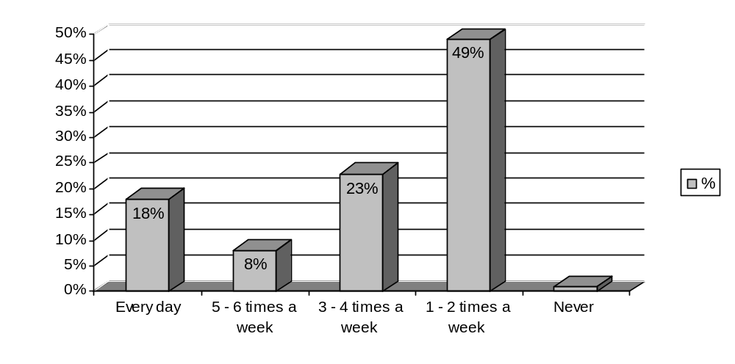 Base: 136

Question 3a: Would you consider your use of the park to be seasonal?

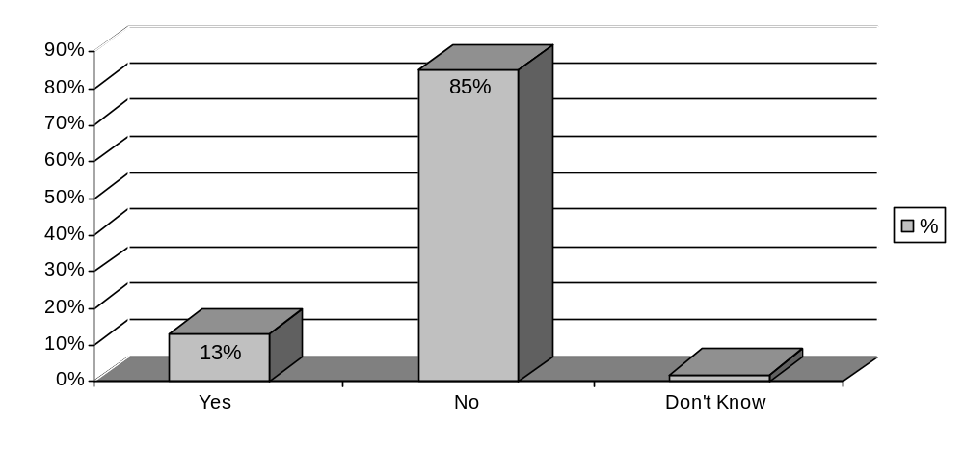Base: 138

Question 3b: If yes, when are you most likely to use the park? (tick all that apply)
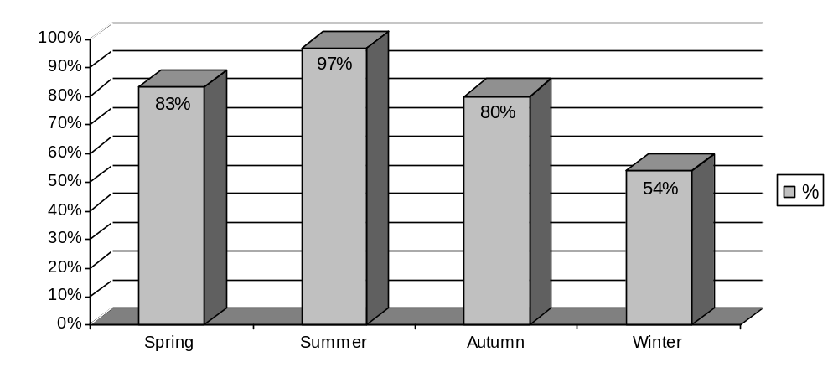Base: Spring, 34; Summer, 40; Autumn 32; Winter 22

3. Park Safety

Question 4a: How welcoming or otherwise would you say the park is?

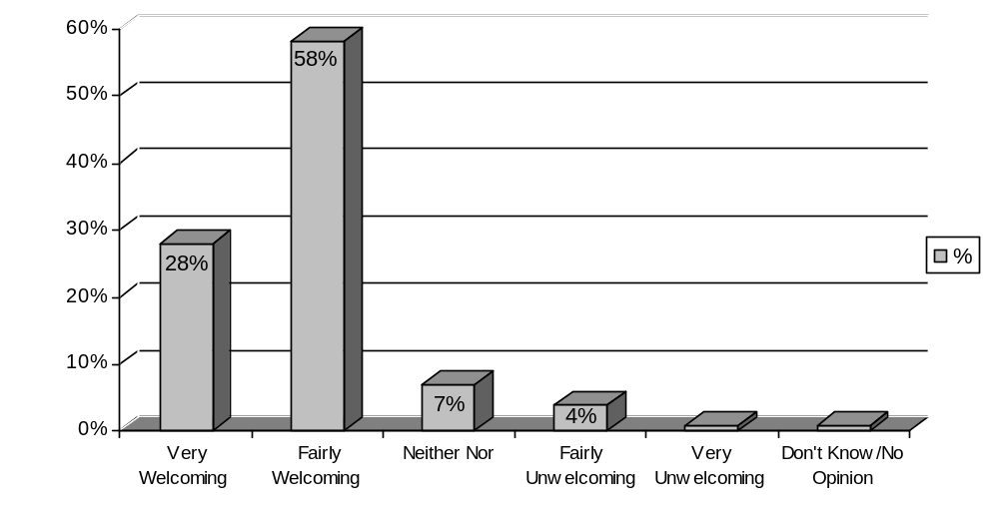Base: 138

Question 4b: If unwelcoming, please provide details

In terms of making the park feel unwelcome, a lack of signage in and around the park was mentioned, as well as limited information on what activities are available or events that are happening.

‘There is very little information available to people when they
enter the park as to what the park offers.’

The issue of personal safety and anti-social behaviour was also highlighted, particularly in the evenings. Respondents felt there was an issue with alcohol consumption and drug taking, which made park users feel intimidated.

Question 5: How safe or otherwise do you feel in the park?

Time | Very Safe (%) | Fairly Safe (%) | Neither Nor (%) | Fairly Unsafe (%) | Very Unsafe (%) | Do not use park at this time (%) | Don’t Know (%) | Base
Morning | 56 (42%) | 61  (45%) | 5  (4%) | 7  (5%) | 1  (1%) | 3  (2%) | 1  (1%) | 134
Afternoon | 56  (41%) | 70  (51%) | 3  (2%) | 5  (4%) | - | 1  (1%) | 1  (1%) | 136
Evening | 3  (2%) | 31  (23%) | 16  (12%) | 22  (16%) | 24  (18%) | 35  (26%) | 2  (1%) | 133

Question 6: In your opinion, how much of an issue, or otherwise, are the following in the park?

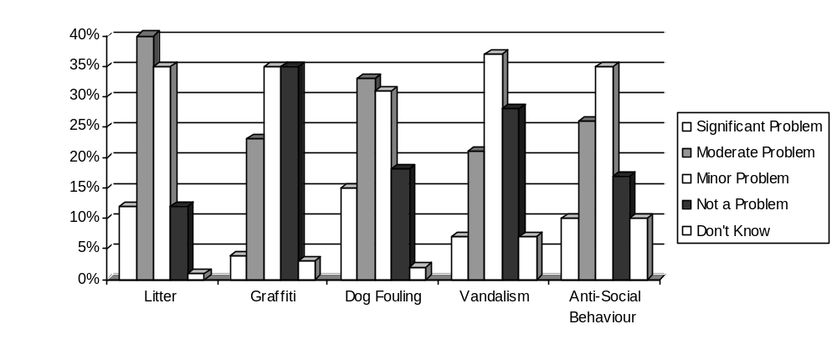 Base: Litter, 134; Graffiti, 128; Dog Fouling, 130; Vandalism, 126; ASB, 133

Question 7: Are there any other issues which you feel are a problem?

Other issues which respondents felt were problematic included alcohol consumption and drug taking and related anti-social behaviour, compounded by a lack of adequate lighting in some areas. Also highlighted was poor drainage in places, which leads to persistent flooding during the winter months or spells of heavy rain.

The issue of litter was mentioned by respondents as a problem across the park. However, specific reference was made on a number of occasions about the pond area, both in terms of general litter and as a result of excessive feeding of the ducks.

Parking in and around the GOALS facility was also seen as causing problems; a perceived lack of parking facilities has resulted in parking elsewhere within the vicinity, causing obstructions for other users and damage to the grass.
4. Park Information and Features

Question 8: To what extent do you agree or disagree with the following statements regarding information provision WITHIN and SURROUNDING the park?

 | Strongly Agree (%) | Agree (%) | Neither Nor (%) | Disagree (%) | Strongly Disagree (%) | Don’t Know (%)
There are sufficient signs providing direction WITHIN the park | 21  (16%) | 64  (48%) | 22  (16%) | 19  (14%) | 2  (1%) | 5  (4%)
There are sufficient signs providing direction in the area SURROUNDING the park | 7  (5%) | 37  (28%) | 32  (24%) | 41  (31%) | 2  (1%) | 13  (10%)
There is sufficient  information about specific features WITHIN the park | 9  (7%) | 42  (32%) | 22  (17%) | 45  (34%) | 10  (8%) | 4  (3%)
Base: 133

Question 9: How would you rate the following aspect of the park in terms of their maintenance?

 | Very Good (%) | Good (%) | Neither Nor (%) | Poor (%) | Very Poor (%) | Don’t Know (%) | Base
Grass | 31  (23%) | 89  (66%) | 10  (7%) | 3  (2%) | 2  (1%) | - | 135
Trees | 40  (30%) | 79  (58%) | 11  (8%) | 2  (1%) | 2  (1%) | 1  (*%) | 135
Shrubs | 33  (25%) | 76  (57%) | 12  (9%) | 10  (7%) | - | 2  (1%) | 133
Bedding Displays | 37  (28%) | 60  (45%) | 20  (15%) | 10  (7%) | 4  (3%) | 2  (1%) | 133
Paths | 24  (18%) | 75  (56%) | 21  (16%) | 14  (10%) | 1  (*%) | - | 135
Trails | 17  (13%) | 63  (47%) | 28  (21%) | 13  (10%) | 1  (*%) | 12  (9%) | 134
Seats/Benches | 13  (10%) | 68  (51%) | 27  (20%) | 19  (14%) | 2  (1%) | 5  (4%) | 134

Question 10: Do you agree or disagree with the introduction of more natural features within the park?

 | Strongly Agree (%) | Agree (%) | Neither Nor (%) | Disagree (%) | Strongly Disagree (%) | Don’t Know (%) | Base
Wild Flower Meadows | 73  (54%) | 43  (32%) | 10  (7%) | 5  (4%) | - | 3  (2%) | 134
Wetland Creation | 63  (47%) | 32  (24%) | 20  (15%) | 13  (10%) | - | 5  (4%) | 133
Long Grass (Wildlife) | 72  (54%) | 39  (29%) | 15  (11%) | 4  (3%) | 1  (*%) | 3  (2%) | 134
Bird/Bat Boxes | 80  (59%) | 36  (27%) | 14  (10%) | 1  (*%) | - | 4  (3%) | 135
Hedgerows | 65  (49%) | 40  (30%) | 16  (12%) | 6  (4%) | 1  (*%) | 5  (4%) | 133

5. Park Events

Question 11: How do you feel about the current number of events held in the park?

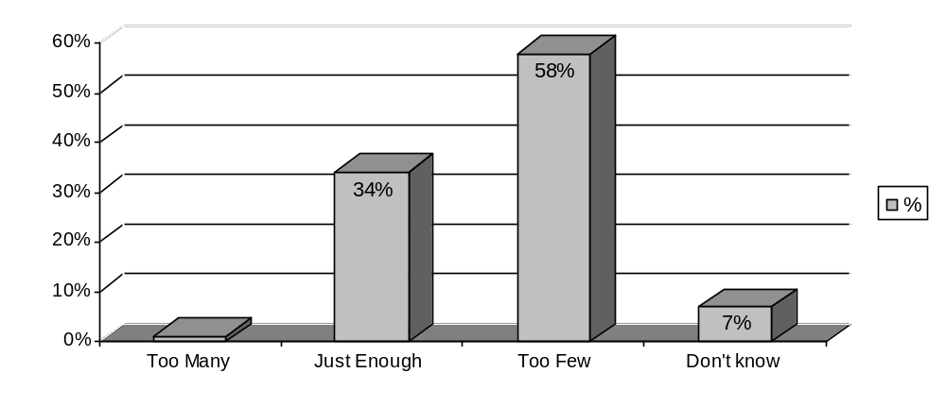Base: 137

Question 12a: Which of the following types of events, if any, do you think there should be more of in the park? (Glasgow Show, Great Scottish Run, galas and fun fairs) (tick all that apply)

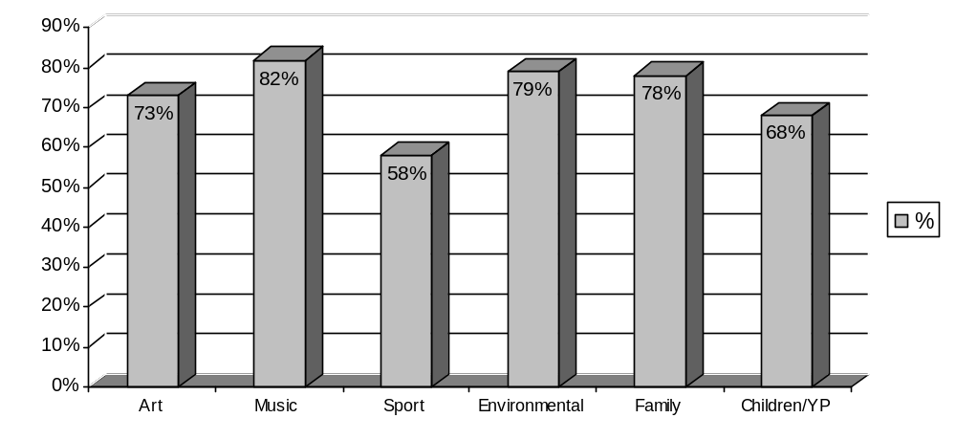 Base: 88

Question 12b: Other, please specify

Other events mentioned by respondents include more farmers markets similar to the one already held in the park, along with more cultural events, which reflect the area and the different communities which use the park.
6. Park Activities

Question 13: How do you feel about the current number of activities available in the park?

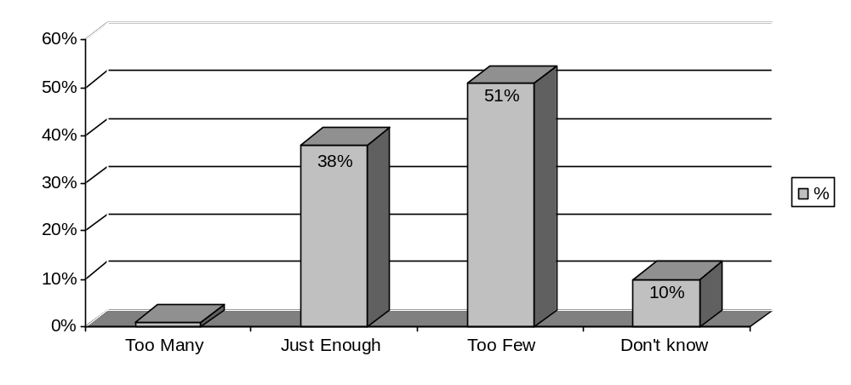 Base: 127

Question 14a: Which of the following types of activities, if any, do you think there should be more of in the park? (Wild About Glasgow, nature walks etc.) (tick all that apply)
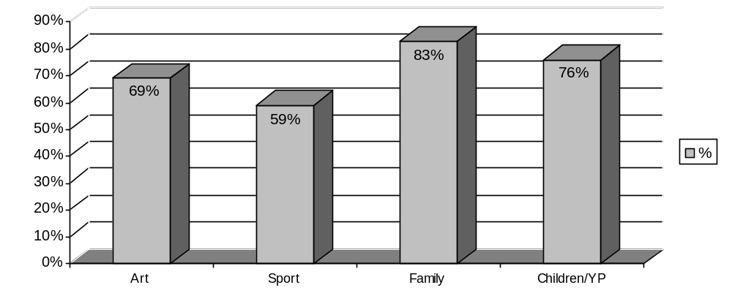Base: 78

Question 14b: Other, please specify

A number of respondents wished to see more water based activities given the existing water features (ponds) including boating and canoeing. Conservation and nature based activities were also highlighted, such as educational walks and tours identifying the plant and wildlife which exist within the park.
7. Park Management and Priorities

Question 15: Please choose from the following list, what you think should be the main priorities for the park. (please select your top three)

The three main priorities highlighted by respondents were:

- Educational activities
- Wildlife
- Trees and woodlands

Other issues identified, include:

- Sports facilities
- Local nature reserve
- Allotments

Question 16: Please tell us what you like best about the park.

The main thing respondents liked about the park was the diversity it offers in terms of the variety of open parkland and wilderness.

‘the variety of different spaces in the park and the creative
ways in which different groups/individuals of the local
community use it.’

These different spaces were seen as providing a peaceful environment within an urban setting. This diversity also extended to the facilities available within the park, with respondents particularly mentioning the Glasshouse, the farmers’ market, play areas, ponds and allotments as being the best parts of the park.

A large number of responses highlighted the views of the city from the flagpole as being spectacular and something that more should be made of with better signage.

Question 17: Please tell us what you like least about the park.

The majority of responses provided have already been mentioned in previous answers (question 7), including litter, personal safety and anti-social behaviour. The only other issue highlighted was a lack of toilet facilities within the park.

8. Parks Management Plans

Question 18: Have you read the Park Management Plan?

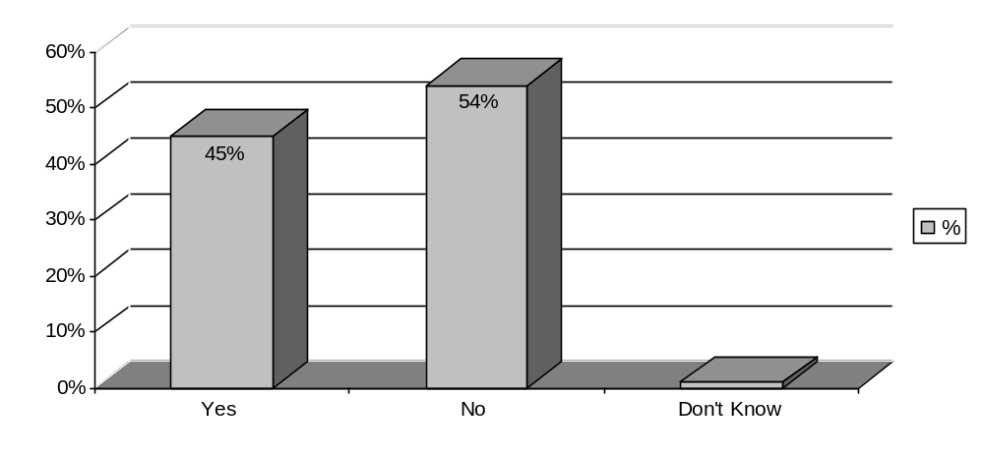 Base: 133

Question 19a: How informative or otherwise did you find the Plan?
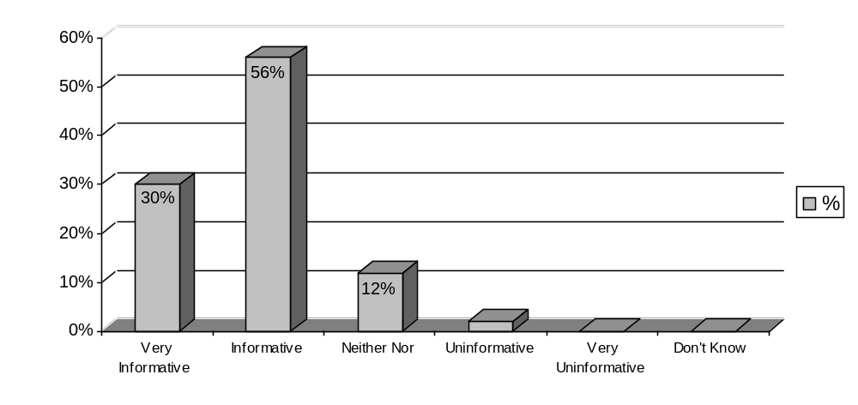Base: 59

Question 19b: If uninformative, what additional information do you think should be included?

A number of respondents mentioned the scale of the Plan, and the time required to read it as a result. It was suggested that a summary, highlighting the key points, would have been useful. There were also a number of comments about the style of the document which was viewed as being ‘too technical’ and using ‘management speak'.

Question 20: To what extent do you agree or disagree with the following aspects of the Plan?

 | Strongly Agree (%) | Agree (%) | Neither Nor (%) | Disagree (%) | Strongly Disagree (%) | Don’t Know (%)
The Plan was easy to read | 9  (15%) | 31  (53%) | 12  (21%) | 4  (7%) | 2  (3%) | -
The format made it easy to follow | 9  (15%) | 36  (62%) | 10  (17%) | 1  (2%) | 2  (3%) | -
The Plan is comprehensive | 11  (19%) | 35  (61%) | 8  (14%) | 1  (2%) | 2  (3%) | -
The Plan reflects the priorities of the park | 6  (10%) | 39  (67%) | 11  (19%) | 2  (3%) | - | -
Base: 58

9. Park Development

Glasgow City Council is committed to future development of the parks; however, in the current economic climate there are restrictions on the type and size of projects that can be undertaken within the next five years. Nevertheless, this should not prevent any long-term aspirations and so, we would like to hear your ideas.

Question 21: Do you agree or otherwise to a review of security measures within the park. (Section 2.5.9 Healthy Safe and Secure - Security)

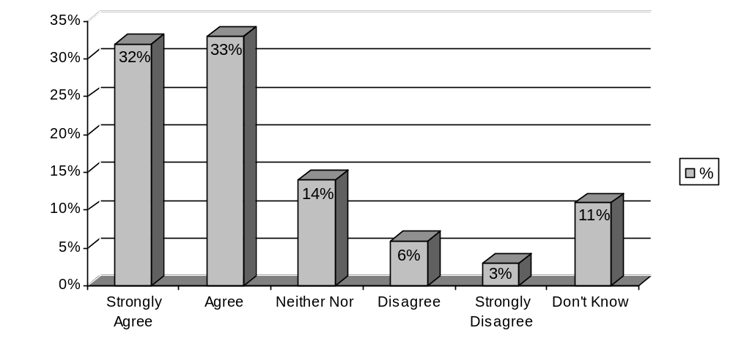 Base: 117

Question 22: Do you agree or otherwise to the development opportunities identified (Section 2.8.11 Conservation and Heritage - Strategic Development Opportunities)

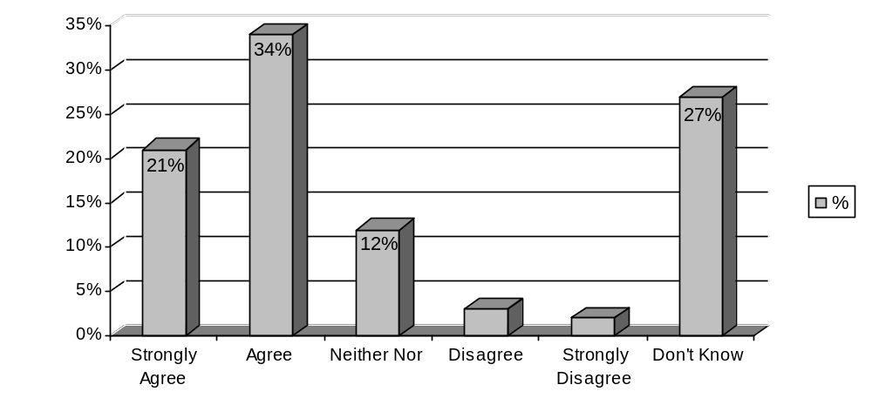 Base: 114

Question 23: Do you agree or otherwise to the development opportunities identified (Section 2.8.20 Conservation and Heritage – Strategic Development Opportunities)
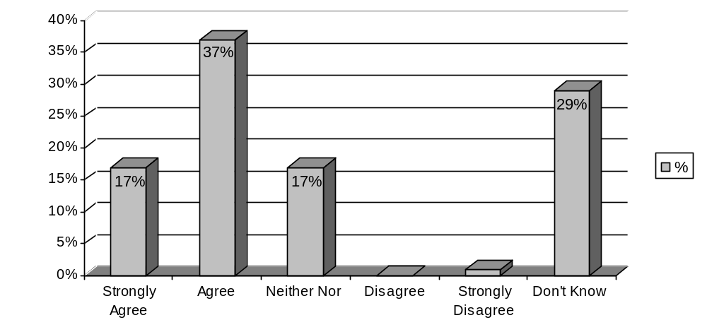Base: 112

Question 24: Do you have any other comments about the park or the management plan?

The majority of issues raised have already been included in the responses so far. Other issues mentioned include the expansion of allotments within the park and the creation of community gardens where local communities could grow produce.

‘A community garden, particularly because of the location
of the park adjacent to so many residential areas.’

The importance of the bandstand redevelopment was again highlighted as an opportunity to create a community space.
10. About You

Question 25: Gender

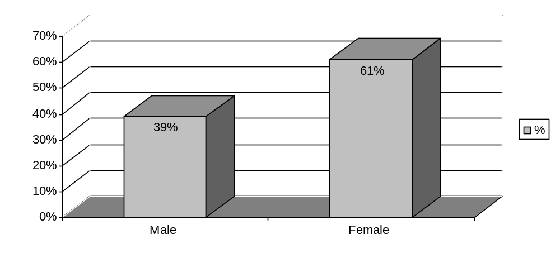Base: 126

Question 26: Age

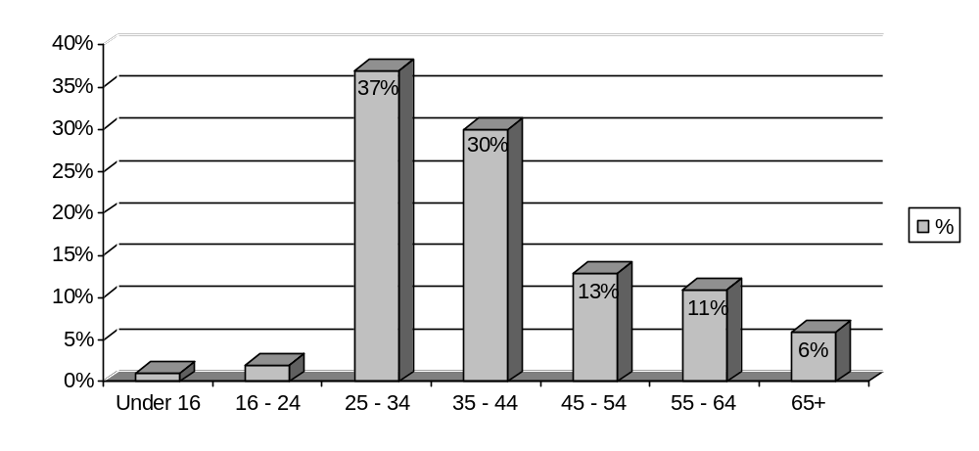 Base: 126

Question 27: Do you have any long-term illness, health problem or disability which limits your activities or the work you can do?
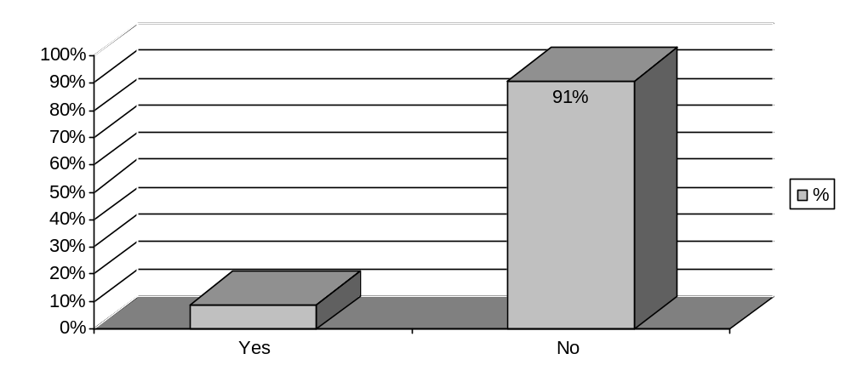 Base: 125

Question 28: How would you best describe you cultural or ethical background?

Cultural/Ethnic Background | Number | Percentage (%)
White Scottish | 88 | 72%
White English | 11 | 9%
White Welsh | - | -
White Northern Irish | 1 | 1%
White British | 12 | 10%
White Irish | 2 | 2%
Gypsy/Traveller | - | -
Polish | - | -
Pakistani, Pakistani Scottish or Pakistani British | - | -
Indian, Indian Scottish or Indian British | 1 | 1%
Bangladeshi, Bangladeshi Scottish or Bangladeshi British | 1 | 1%
Chinese, Chinese Scottish or Chinese British | - | -
African, African Scottish or African British | - | -
Caribbean, Caribbean Scottish or Caribbean British | 1 | 1%
Black, Black Scottish or black British | - | -
Arab | - | -
Other | 5 | 4%
Base: 122

